1. **Data preparation**

**Numpy:** allows us to work with arrays.

**Matplotlib:** allows us to plot charts and graphs

**Pandas:** allows us to plot the dataset and create a matrix of features or preprocess your dataset

**Features/independent variables –** variables containing the properties that you will use to make a prediction which is your **dependent variable vector.**

**iloc (locate indexes) –** take the indexes of the columns and rows we want to extract from the dataset. A trick to take all the rows is by using a **colon** (**:**) which stands for a range. To separate the rows from the columns, use a **comma**

A range in python includes the lower bound but includes the upper bound

dataset.iloc[:, :-1].values : in iloc the order is rows, columns

**ct = ColumnTransformer(transformers=, remainder=”passthrough”) : transformers-** Specifies the kind of transformation we want to do and on which indexes of the columns we want to transform, remainder – specify that we actually want to keep the columns that won’t be applied some transformations. **Passthrough** enables us to **not only** keep the three columns resulting from one hot encoding eg 100, 010, 001

**fit_transform** method doesn’t return it’s output as a numpy array whereby models as a must need the data to be in the form of a numpy array, so you use

**Feature scaling**: scaling all your variables or features to make sure they all take values in the same scale.

Don’t do feature scaling before splitting the dataset to prevent information leakage to the test set

**Note: Standardization works all the time –** puts values of features between -3 and +3 or -2 and +2, while **normalization works when you have a normal distribution of your values –** puts values between 0 and 1

1. **Simple Linear Regression – one independent variable / feature vector**

With **regression** you predict a continuous value while with classification you predict a category.

**The best regression line** is the one where the **SUM(y1-y1`)2** is minimized

**Note: (y1-y1`) is the residual that is the difference between the actual point and the predicted point**

1. **Multiple Linear Regression**

**Anscombe’s quartet:** You can’t simply apply linear regression, you must make sure your dataset is fit for using linear regression.

**Assumptions of linear regression**

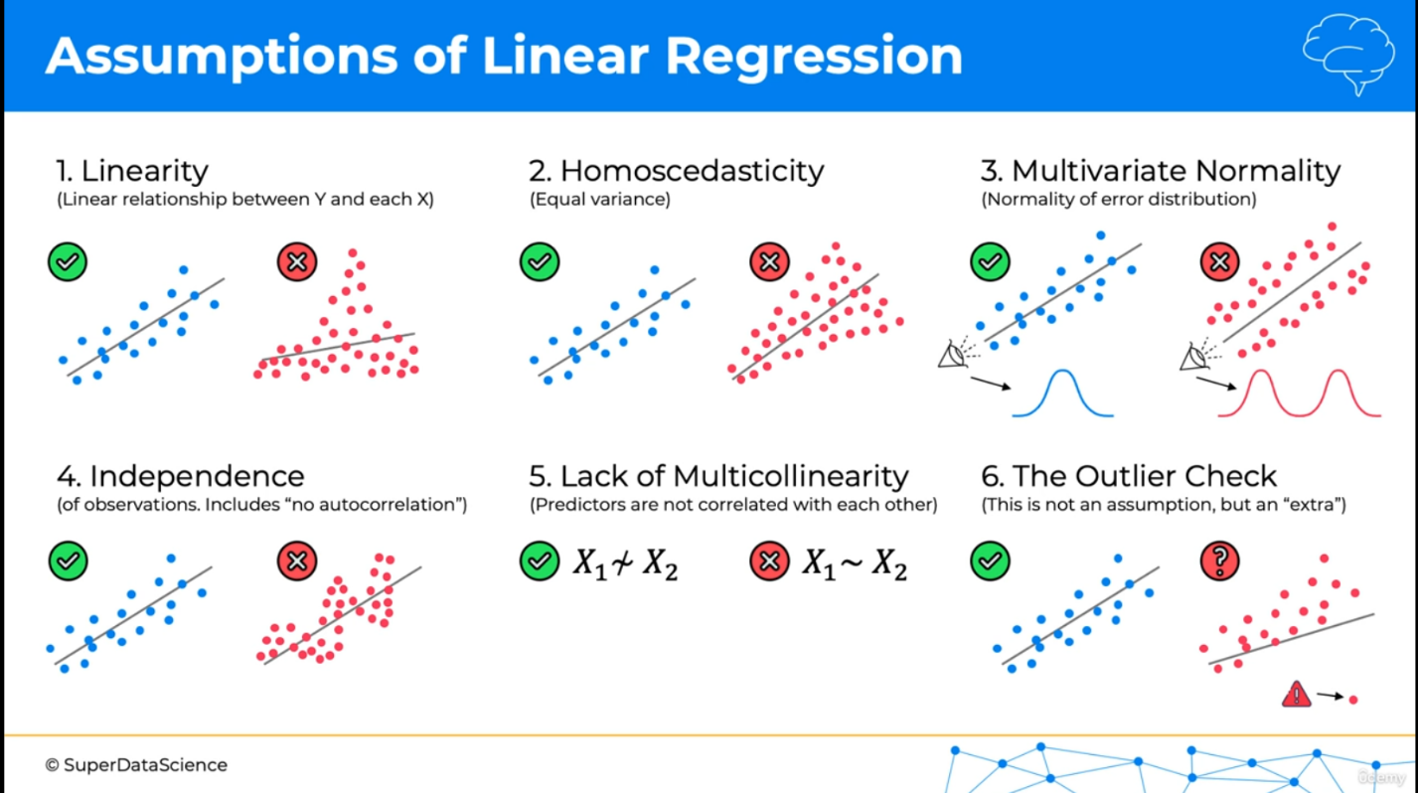

**Independence –** shouldn’t see a pattern in our data eg forex data

**When** you have categorical column data as one of your independent variables, then it’s necessary to use **Dummy variables.**

**Multicollinearity:** situation where one or more independent variables predict one another

**Whenever you’re building a model** only include one dummy variable

**Statistical significance**

**5 methods of building models**

1. All-in
2. Backward Elimination
3. Forward selection
4. Bidirectional Elimination
5. Score comparison

**NOTE:** Stepwise regression refers to 2, 3, and 4 and sometimes just 4.

1. **All-in** – use all your independent variables

**When would you do this**;

* **Prior knowledge**
* **You have to**
* **Preparing for backward Elimination**

1. **Backward Elimination**

**Step 1.** Select a significance level to stay in the model eg SL = 0.05

**Step 2.** Fit the full model with all possible predictors

**Step 3.** Consider the predictor with the highest P-value. If P > SL, go to STEP 4, otherwise go to FIN (finish ie model is ready)

**Step 4.** Remove the predictor

**Step 5.** Fit model without this variable

**After step 5, go back to Step 3**

1. **Forward Selection**

**Step 1.** Select a significance level to enter the model (e.g SL = 0.05)

**Step 2.** Fit all simple regression models y-xn Select the one with the lowest P-value

**Step 3.** Keep this variable and fit all possible models with one extra predictor to the one you already have

**Step 4.** Consider the predictor with the lowest P-value. If P < SL, go to STEP 3, otherwise go to FIN: Keep the previous model

1. **Bidirectional Elimination**

**Step 1:** Select a significance level to enter and to stay in the model

**Step 2:** Perform the next step of Forward selection (new variables must have: P < SLENTER to enter)

**Step 3:** Perform ALL steps of Backward Elimination (old variables must have P < SLSTAY o stay)

**Step 4:** No new variables can enter and no old variables can exit

1. **All Possible Models**

**Step 1:** Select a criterion of goodness of fit (e.g. Akaike criterion)

**Step 2:** Construct All possible regression models: 2N – 1 total combinations

**Step 3:** Select the one with the best criterion

**NOTE:** In multiple linear regression there is absolutely no need to apply feature scaling and also to check for the assumptions of linear regression

1. **Polynomial linear regression**

Handy when trying to determine how epidemics spread over an area

Though the x values are polynomial, we focus on expressing the coefficients as linear values and that’s why it’s called Polynomial **Linear** regression

1. **Linear Support Vector Regression**

Vectors that support the formation of the Epsilon tube or Error tube

1. **Non Linear Support Vector Regression**

**Kernels –** can learn linear relationships ie Linear Kernels or **Non- Linear Relationships ie** Non – linear kernels eg Gaussian Radial Basis Function RBF, Polynomial Kernel, and Gaussian Kernal

1. **CART – Classification and Regression Trees –** you don’t have to use feature scaling on decision tree regression or random forest regression
2. **Essemble Learning** – take multiple algorithms or the same algorithms multiple times to make something more powerful.

**CLASSIFICATION**

1. **Logistic regression:** predicting a categorical dependent value from a number of independent variables. It uses a sigmoid curve to predict data.

**Likelihood = Probability of saying yes * Probability of saying no**

The logistic regression curve is the one with the **maximum likelihood**

1. **Support Vector Machine:** In SVM the vectors, represent the extreme cases in our dataset.
2. **KNN**
3. **Kernel SVM:** evolves around mapping to a higher dimensional space in order to obtain our non-linear separator. Used when you have categories that are not linearly separable.

**When** you map from a one dimensional space to a 2D space, the separator is a line, when you map from a 2D space to a 3D space, the separator is a hyperplane.

**Problem:** Mapping to a higher dimensional space can be very compute intensive. Hence it’s not the best thing for big datasets.

**Hence we do it differently using the Gaussian RBF Kernel** that allows us to still do the computation in the same dimensional space. If sigma is small, your circumference or boundary is small, if big, the circumference is bigger

1. **Naïve Bayes Classifier**
2. **Decision Trees:** CART – Classification and Regression Trees

**It** works off splits.

**We** change the criterion to ‘entropy’

1. **Confusion Matrix and Accuracy:** Accuracy Rate = TN + TP / Total

Error Rate = FP + FN / Total

1. **Accuracy Paradox:** completely abandoning your model and still getting a good accuracy hence accuracy alone as a model evaluation may not be efficient enough.
2. **Cumulative Accuracy Profile** is then used to get a better evaluation of the model.

**Perfect model, good model and random model**

X < 60 – Rubbish

60 < X < 70 – Poor

70 < X < 80 – Good

80 < X < 90 – Very Good

90 < X < 100 – Too Good : (**Note: may have overfitting)**

1. **ROC – Receiver Operating Characteristic**

**CLUSTERING**

1. **K- Means Clustering:** involves continuous determining first the number of clusters you want, if 2, randomly place 2 points on the dimension, then get a line that is equidistant to the points and then get the center of mass and shift the points to their appropriate center of mass and repeat the process accordingly.

**Elbow method:** pretty good method for determining the optimal number of clusters

**K-Means++** - used to escape the random initialization trap of the centroids.

**Here** we deploy a weighted random fashion of choosing a centroid hence reduces the change of random initialization trap.

**WCSS (Within-Cluster Sum of Square)** the sum of the squared distance between each point and the centroid in a cluster.

**The best number of clusters is the one where the WCSS starts reducing gradually.**

1. **Hierarchical clustering:** types include **Agglomerative** – bottom up approach and **Divisive** – top bottom approach.

**Dendogram –** used to find the optimal number of clusters

**ASSOCIATION RULE LEARNING – people who bought this, also bought that**

1. **Apriori:**  it has 3 parts; support, confidence and the lift

**Movie recommendation: support(M)** = number of user watchlists containing M / number of user watchlists

**Confidence(M1 -**> **M2)** = number of user watchlists containing M1 and M2 / number of user watchlists containing M1

**Lift(M1 -**> **M2)** – confidence (M1 -> M2) / support (M2) – metric for measuring the association rule.

1. **Eclat:** similar to Apriori but here **M** stands for a set of two movies or more. Eg number of transactions containing A, B, C divided by the total number of transactions

**REINFORCEMENT LEARNING**

1. **Upper Confidence Bound -** deals with decreasing bounds after multiple tests in search of the expected value.

**You have to assume each item / sample has a fixed conversion rate.**

1. **Thompson Sampling Algorithm** – we construct distributions of where the actual expected value might lie.

**NOTE**:

1. Thompson sampling is a probabilistic algorithm while UCB is a deterministic algorithm.
2. Thompson sampling can accommodate delayed feedback while UCB requires update at every round.

**In the problem of ads we’re trying to identify which distribution curve among the ads has the highest conversion rate.**

**NATURAL LANGUAGE PROCESSING**

**Types of NLP**

1. NLP eg If/Else rules (Chatbot), Audio frequency components analysis (Speech recognition), Bag-of-words model (Classification)
2. Deep NLP where we have CNN for text recognition (Classification) , Seq2Seq models ie Sequence to Sequence models which is very powerful.

**NB:**

* We need only about 20,000 words to make up a good Bag of Words cause a person usually knows about 20,000 – 35,000 words.
* SEO stands for Start of Sentence and is reserved for the first position and EOS stands for End of Sentence and is reserved for the second position and the last position is reserved for Specia Words ie any kind of words we can’t recognize from the 20,000.

**DEEP LEARNING**

**Activation Functions:**

1. **Threshold Function:** if value is less than zero, then the threshold function passes on zero.. if it’s more than zero or equal to zero it passes on 1.

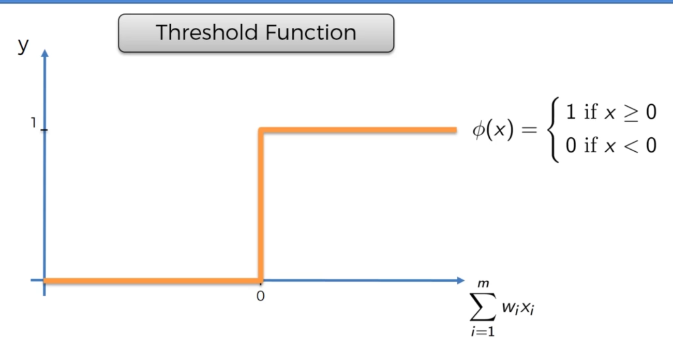

1. **Sigmoid Function:** very useful in the final layer.

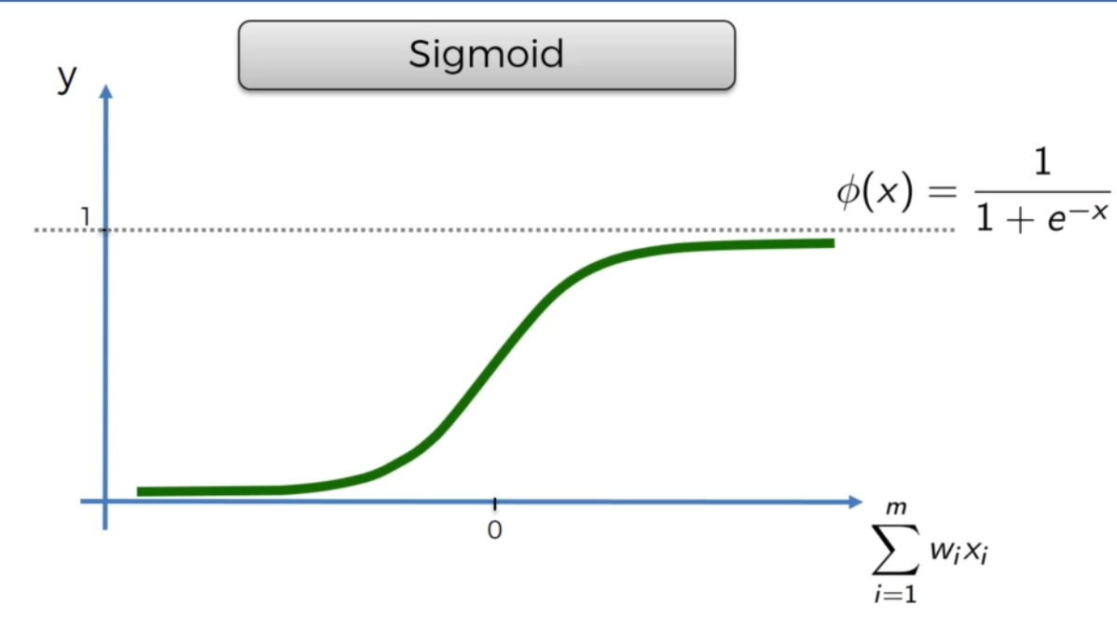

1. **Rectifier function:** very popular

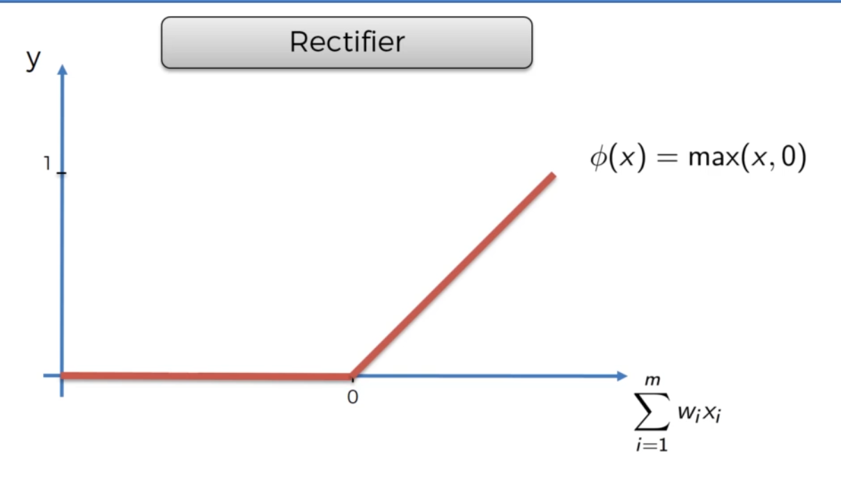

1. **Hyperbolic tangent function**

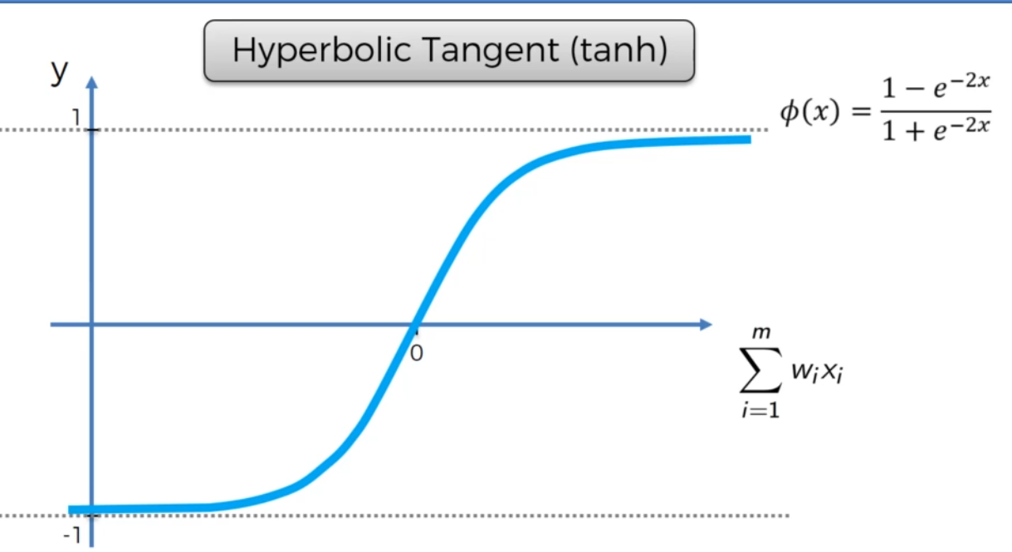

**NOTE:**

1. If your output value is 0 or 1, then there are two functions you can use ie the **Threshold function and the sigmoid function**
2. In the hidden layers you apply rectifier function and in the output layer you apply the sigmoid function.

**How do Neural Networks work?**

* **Combines parameters into a single attribute that helps in evaluation.**

**How do Neural Networks Learn?**

**Single layer feed forward neural network or perceptron-**

**Cost function = 1/2(output value – actual value)^2 –** what is the error in the prediction. We want to minimize this cost function.

Weights are updated in order to minimize the cost function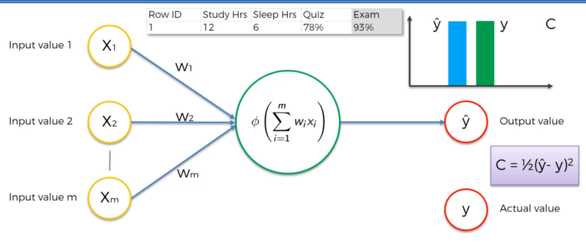

**Backpropagation:** Continuous running your neural network and updating your weights in order to minimize your cost function.

**Gradient Descent:**

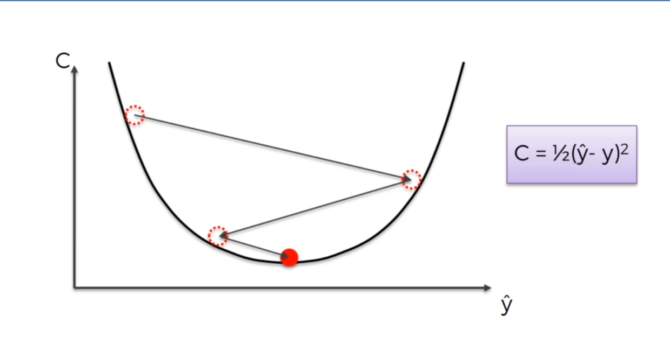

Trying to minimize the cost function in a very efficient way. Gradient descent though requires the cost function to be convex. If it’s applied to one that’s not convex you can have a situation of meeting the local minimum cost function instead of the global one.

* **Stochastic Gradient Descent:** it takes row by row and adjust cost function and weights, while normal gradient descent takes all the rows then adjust the weights.
* It’s faster than batch gradient hence you don’t have to keep all rows in memory.
* Batch gradient method is deterministic hence good while stochastic method is random.
* 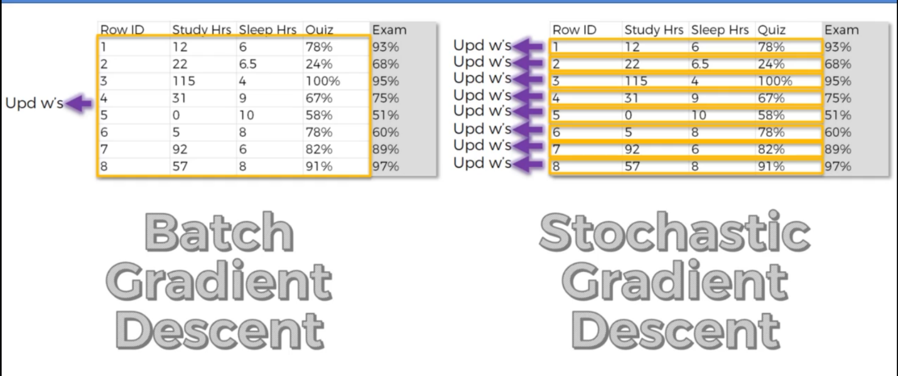
* **Backpropagation**

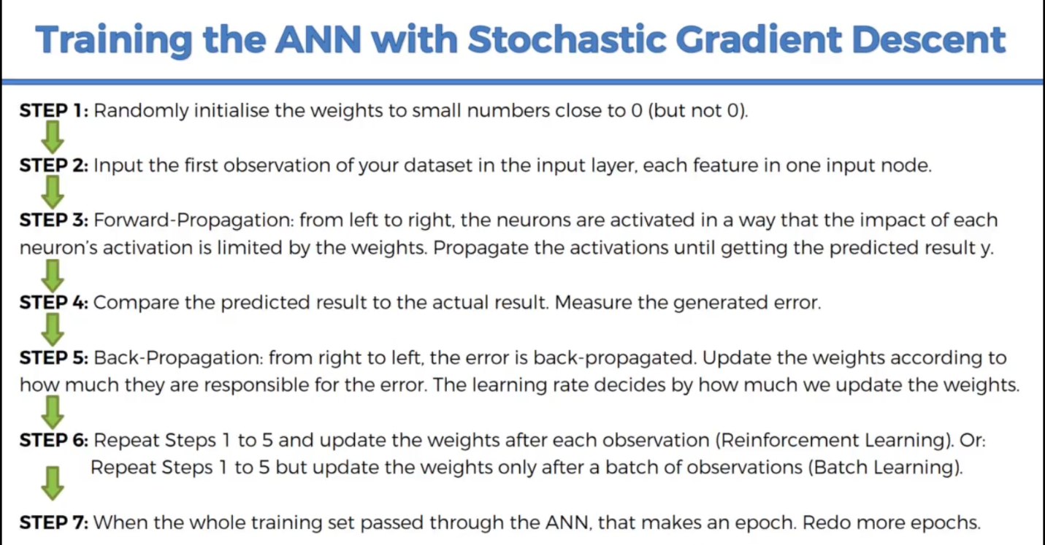

**LOOK AT ANN WITH REGRESSION**

**CONVOLUTIONAL NEURAL NETWORKS**

**Steps:**

* Convolution
* Max Pooling
* Flattening
* Full connection

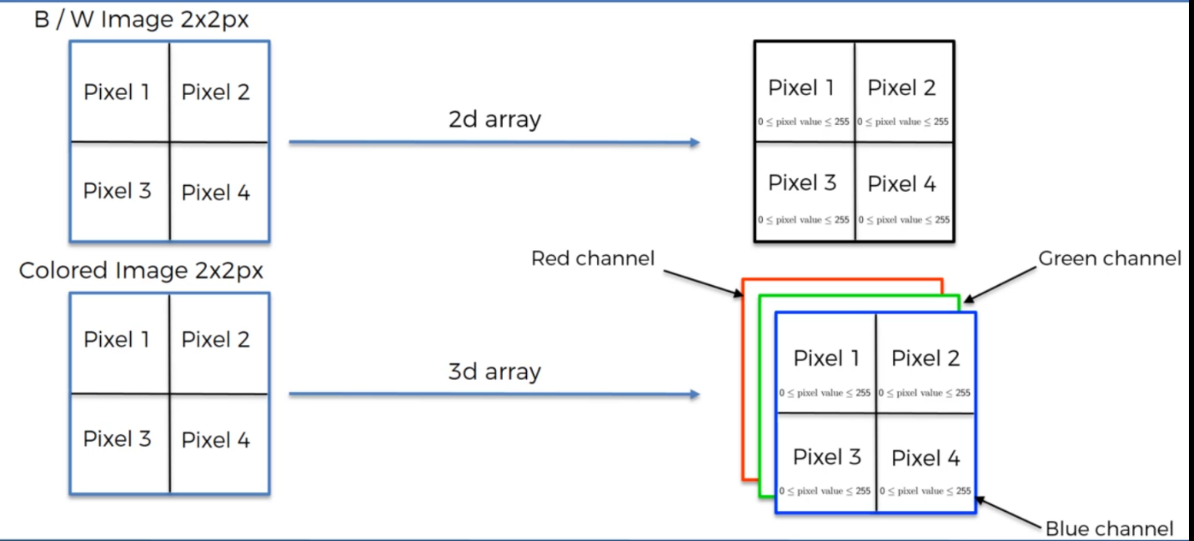

**Read:** Introduction to Convolutional Neural Networks By Jianxin Wu(2017)

1. **Convolution**

Input image * Feature Detector (3 by 3… or 5 by 5 or 7 by 7) aka kernel / filter. => Feature Map (Convolved feature / Activation map)

**Checkout gimp.org**

* **So basically the convolution finds features in your image through a feature detector and puts them in a feature map**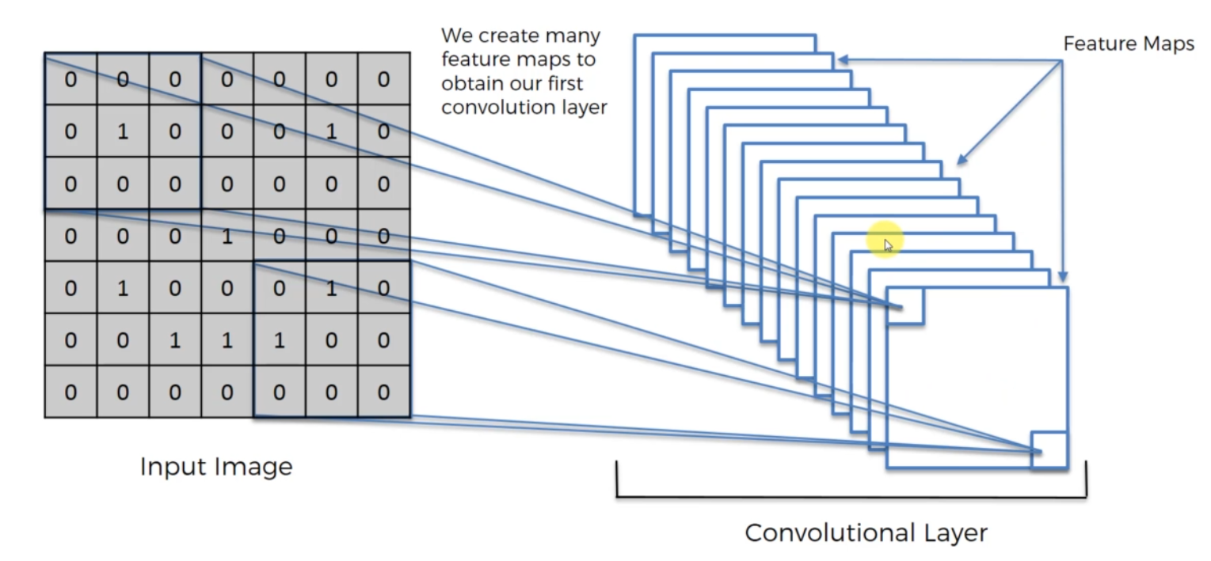

**ReLu Layer- Rectifier Linear Units**

Add the rectifier to increase non-linearity in our network because images themselves are nonlinear.

Understanding Convolutional Neural Networks with a Mathematical Model By C C Jay Kuo(2016)

Delving Deep into Rectifiers Surpassing Human-Level Performance on ImageNet Classification By Kaiming He et al (2015)

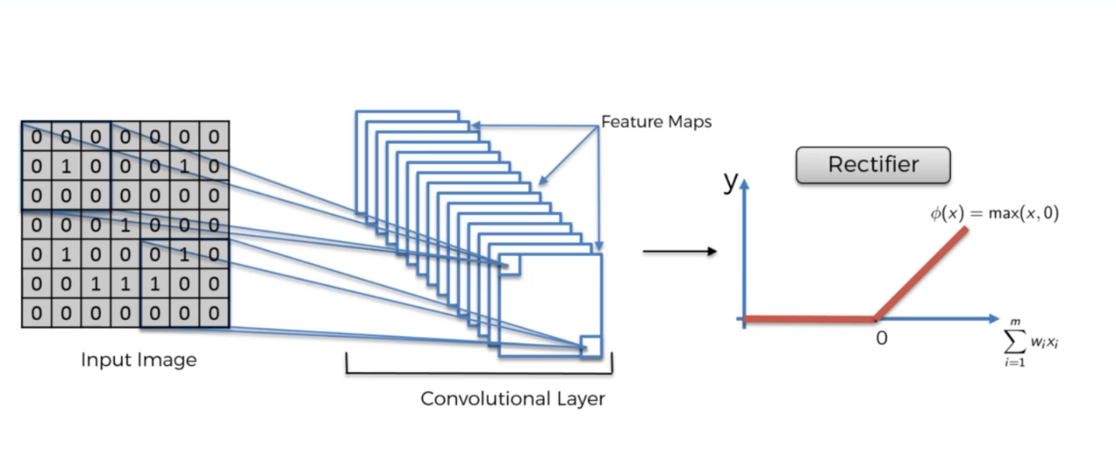

1. **Max Pooling: (Pooling aka downsampling)**

**Spacial Invariance –** model doesn’t care where the features are located.

**Stride –** number of units or columns to compare, usually 2.

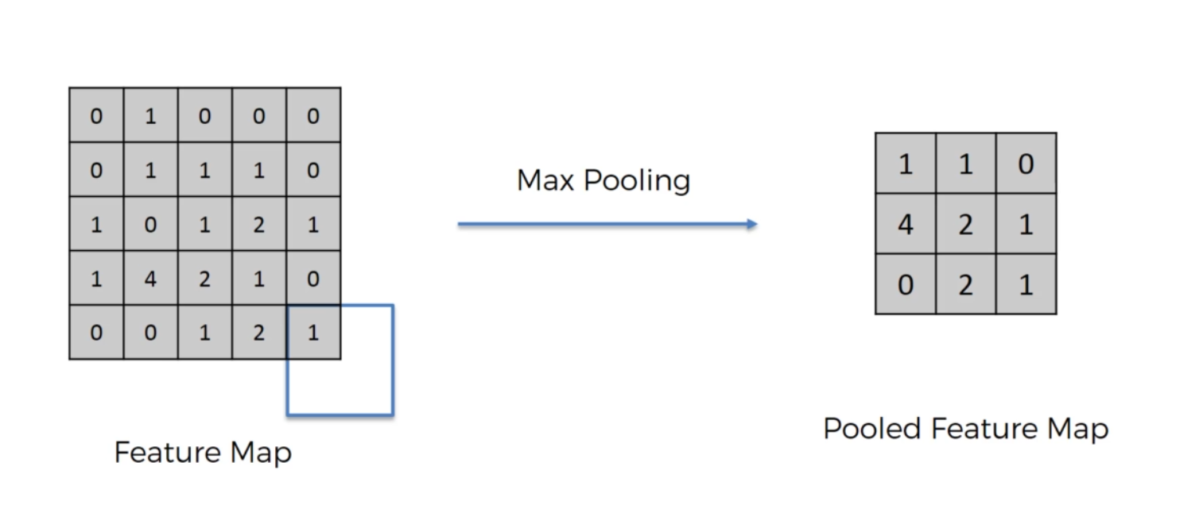

The figure above demonstrates max pooling. Others include mean pooling, sub sampling , etc **Pooling preserves the features, introduces spacial invariance, reduces the size by 75% and reduces the number of parameters going into our final layers of the convolutional network hence reducing over fitting.**

**Read:** Evaluation of Pooling Operations in Convolutional Architectures for Object Recognition By Dominik Scherer et al. (2010)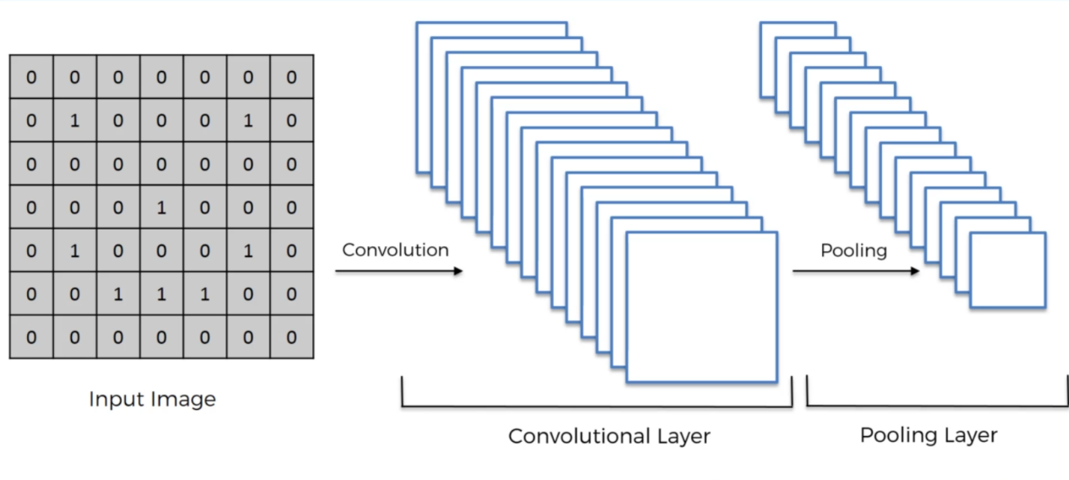

1. **Flattening**

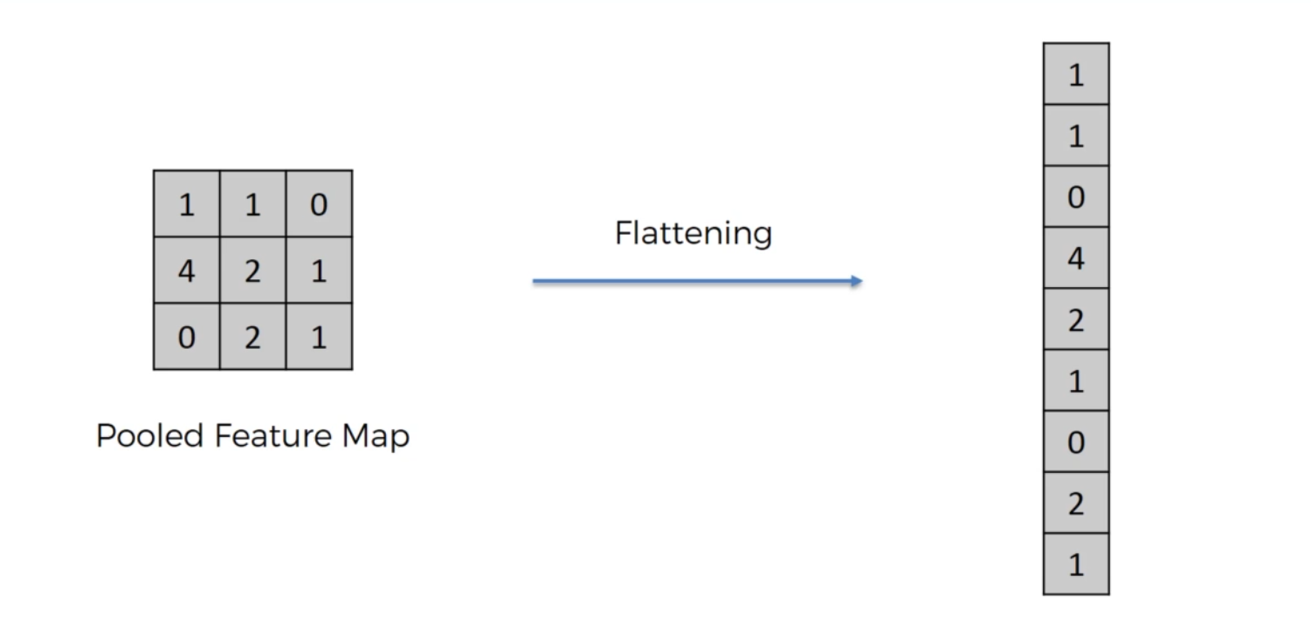

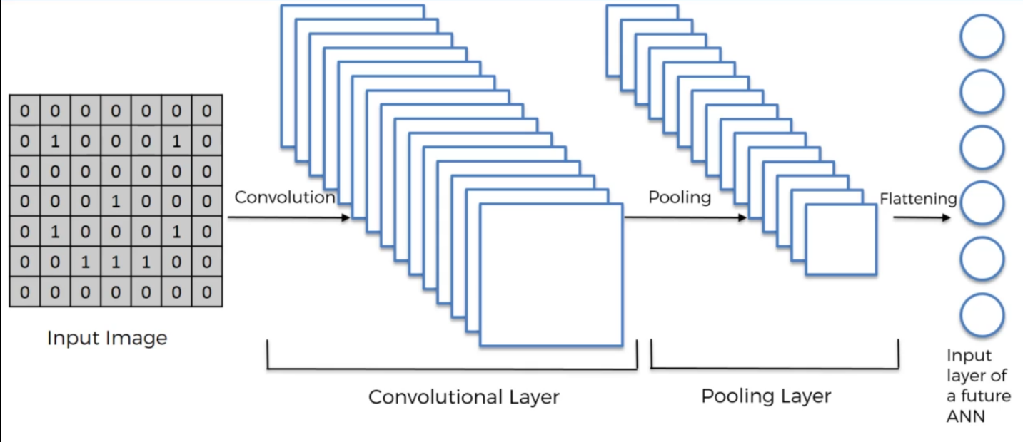

1. **Full Connection**

**Note:** In ANN hidden layers don’t have to be fully connected while in CNN hidden layers can be fully connected.

The neurons in the final connected layer **vote.**

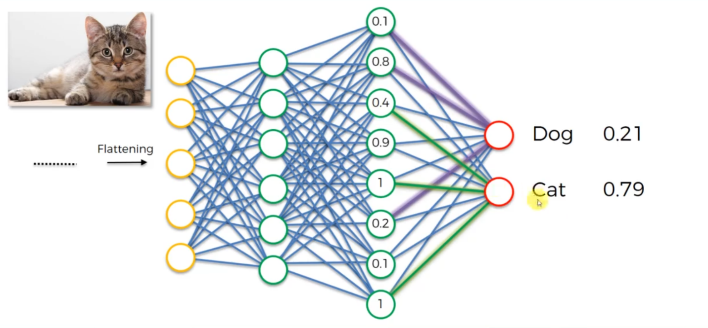

**Summary**

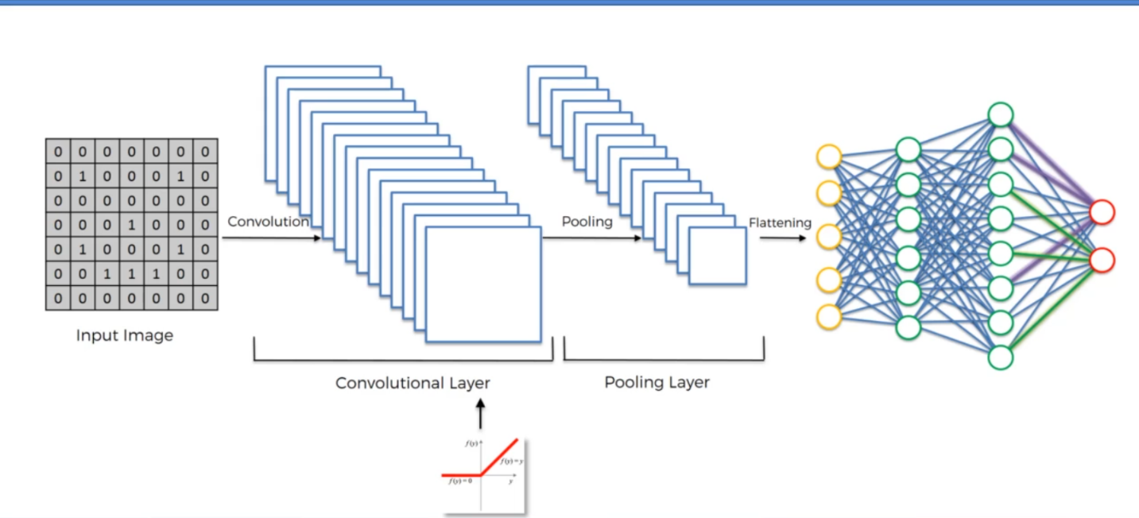

**Read:** The 9 deep learning papers you need to know about Adit Deshpande (2016)

**Softmax and Crossentropy**

**Softmax function** helps us make the predictions of the outputs between 0 and 1 hence the probabilities among the different functions will be relatable.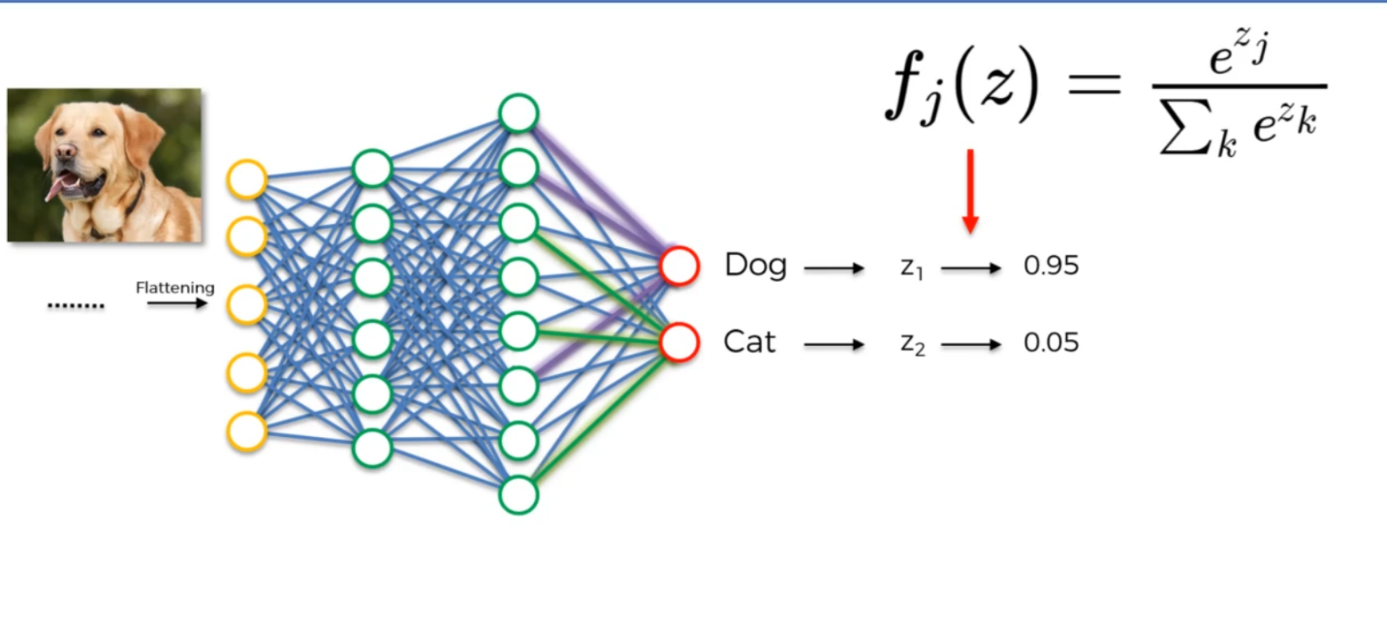

**Crossentropy**

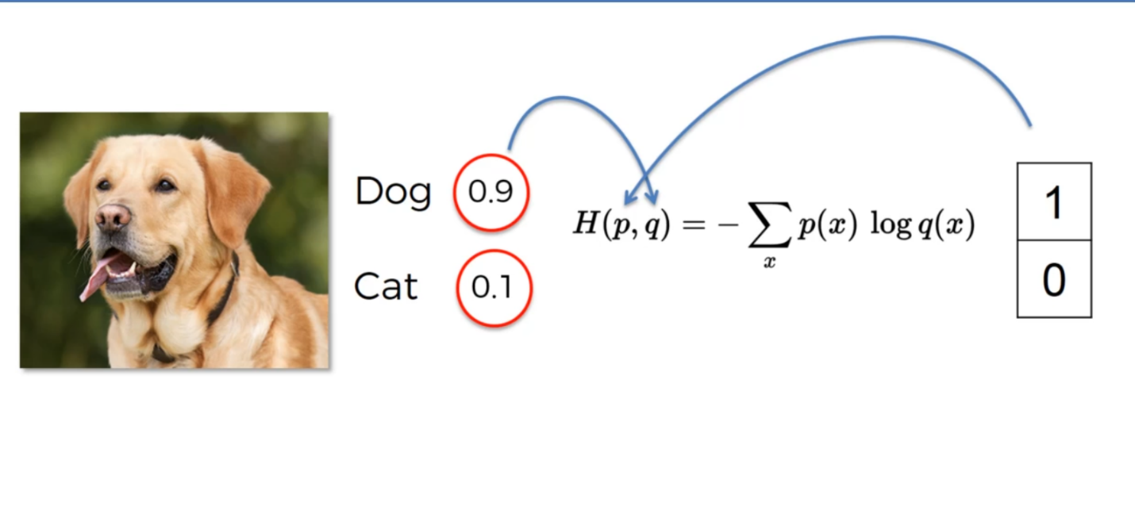

**Crossentropy helps us easily identify the significance of the variance of our errors compare to MSE.**

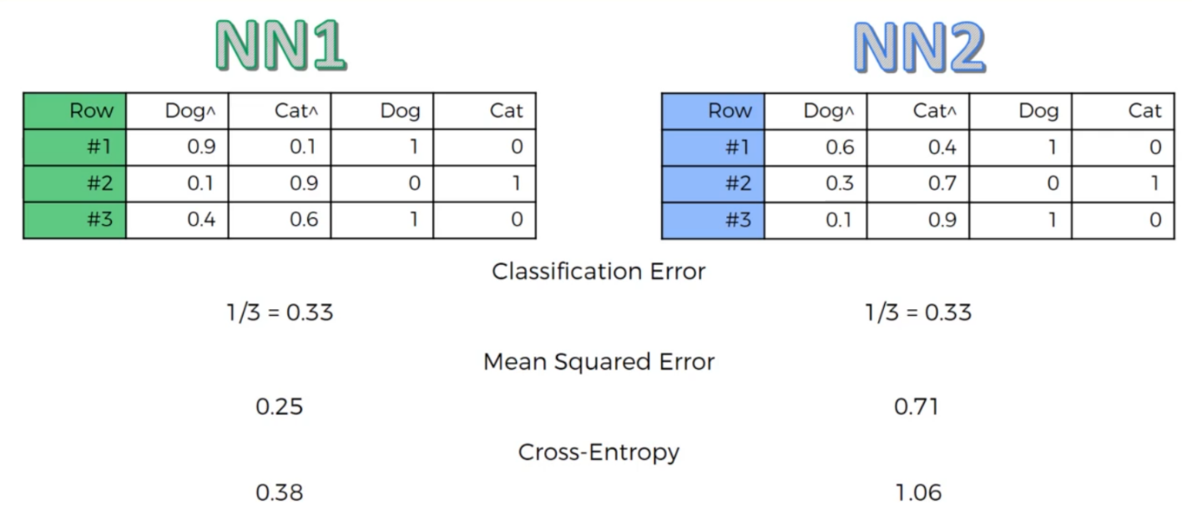

**Reading: A friendly Introduction to Cross Entropy Loss by Rob DiPietro**

**How to implement a neural network Intermezzo 2**

**DIMENSIONALITY REDUCTION**

1. **Principal Component Analysis:**

**Goal : Identify and detect correlation between values**

**Or: Reduce the dimensions of a d-dimensional dataset by projecting it onto a (k)- dimensional subspace (where k <d)**  
Used for :

* Noise filtering
* Visualization
* Feature Extraction
* Stock Market predictions
* Gene data analysis

**Instead of predicting the values it tries to find the relationship between the X and Y values**

**Weakness:** Highly affected by outliers in the data

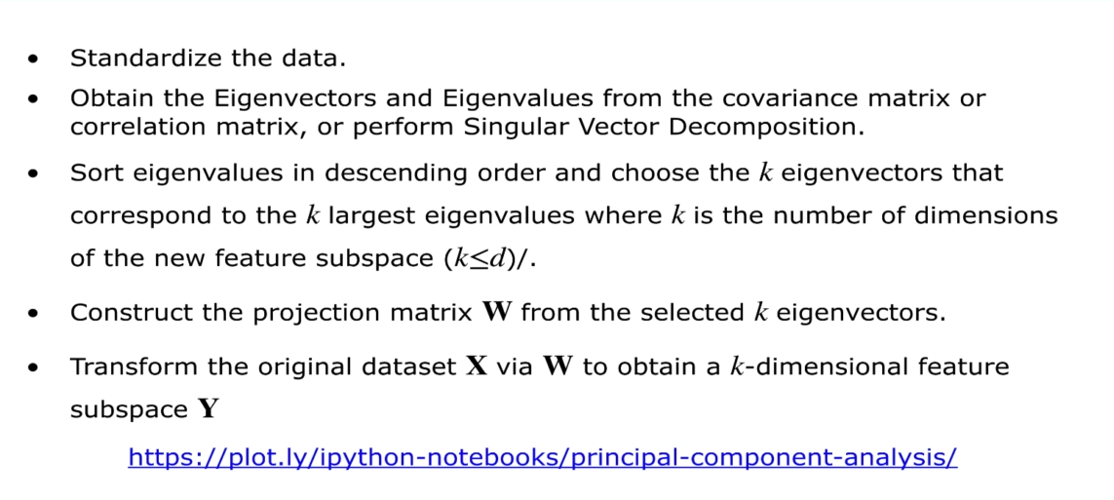

**NOTE: With Dimensionality reduction you get extracted features out of the existing features.**

**Apply PCA before training your model on the training set**

1. **Linear Discriminant Analysis (LDA)**

LDA differs because in addition to finding the component axises with LDA **we are interested in the axes that maximize the separation between multiple classes**.

**NOTE: LDA is supervised while PCA is unsupervised.**

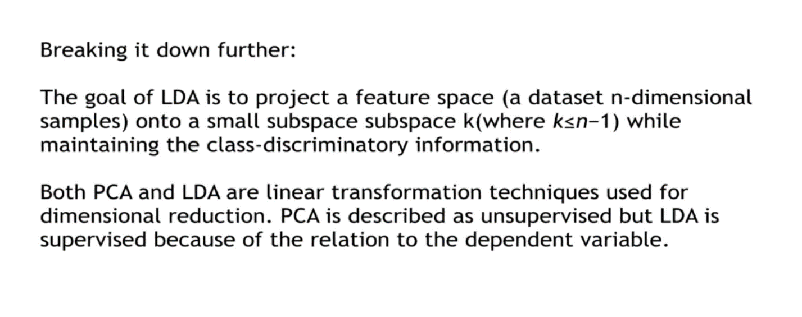

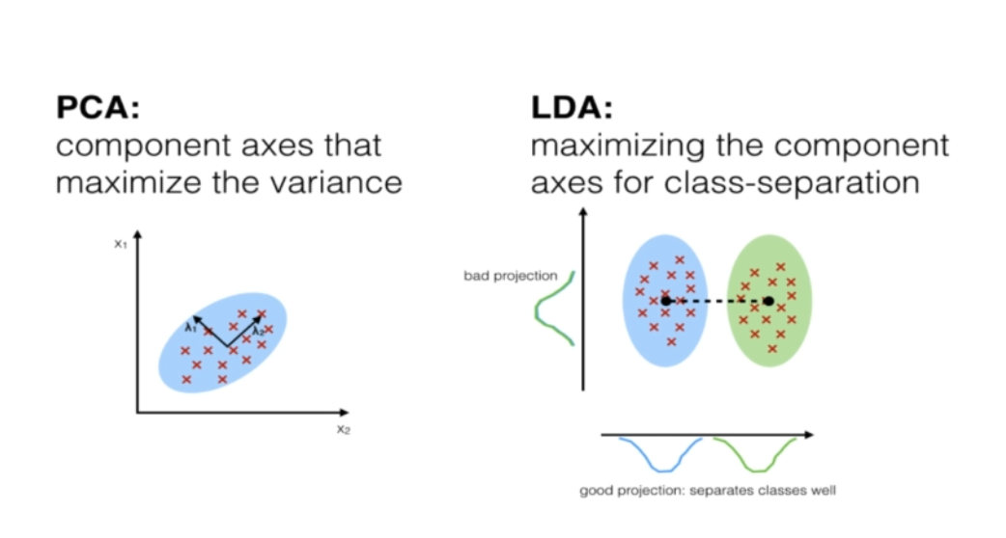

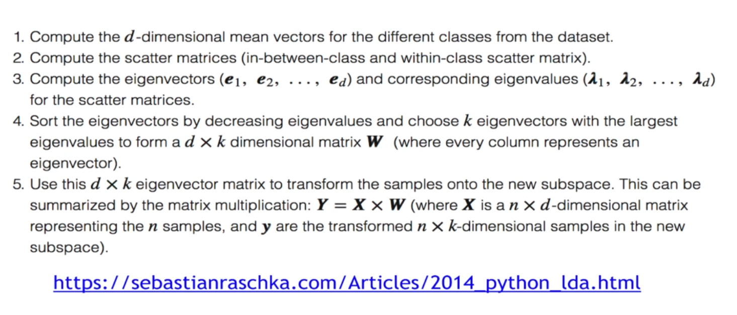

**MODEL SELECTION AND BOOSTING**

1. **K Folds Cross Validation –**most efficient way to evaluate your model by creating more test sets on which to evaluate the model
2. **Grid search –** getting the best hyperparameters for your model. Hyperparameters are parameters that are not learned during training.
3. **XG Boost**